Chemistry 260 Summer 2025

E9 The Aldol Reaction & Evaluation of Sunscreen Components

**<<This report will be completed as an “in-lab assignment” that you will work on and hand in at the end of the period. You can do some of the work (e.g., the NMR) in advance.>>**

Name: ______________________________ Section:_______________ Date: ___________________________

**Observations (1 mark)**

**Reagents and Products Tables (1 mark; 0.5 mark each)**

**Table 1.** Reagents for the aldol reaction. Only calculate moles for the compounds you used.

|  |  |  |  |  |
| --- | --- | --- | --- | --- |
| Compound | MW (g/mol) | Used | moles | Physical and Safety Data |
| 3 M Sodium hydroxide | 40.00 | 10 mL |  | Toxic; corrosive. |
| benzaldehyde | 106.12 | 1.0 mL |  | Irritant, harmful, Bp 178-179 °C |
| Ethanol | 46.07 | ~8 mL | N/A (solvent) | Flammable liquid; irritant. Bp 78o; density 0.789 g/mL. |
| Acetone | 58.08 | 290 mg |  | Highly flammable; irritant to eyes. Bp 56o; density 0.791 g/mL |
| Cyclopentanone | 84.12 | 420 mg |  | Flammable, irritant, Bp 130-131 °C |

**Table 2.** Product of the aldol reaction.

|  |  |  |  |  |  |
| --- | --- | --- | --- | --- | --- |
| Compound | Physical Description | MW (g/mol) | Mass Isolated | moles | % yield |
|  |  |  |  |  |  |

**Results**

**Percent Yield Calculation: (1 mark)**

**Melting Range: (1 mark)**

**Table 3**. Melting range analysis of the two products

|  |  |
| --- | --- |
| Name of Product | Melting Range |
|  |  |
|  |  |

UV-Visible Spectroscopy Data: (3 marks)

**Table 4.** UV-vis data for tetraphenylcyclopentadienone

|  |  |  |
| --- | --- | --- |
| Compound | Maximum wavelength (max) | Relative absorbance |
| Dibenzylidenenacetone (**1**) |  |  |
| Dibenzylidenencylopentanone (**2**) |  |  |

Roughly sketch the two UV-vis spectra (label which is which):

**Dilution Calculation:**

Amount of compound used: _____mg Amount of first solution diluted: ______L

Sample calculation:

**NMR Data:**

**Table 5.** Predicted 1H NMR chemical shifts for the alkene protons of dibenzylideneacetone. Use the table on page Y-7 to predict the chemical shift of the two alkene protons. **(1 mark)**

|  |  |  |
| --- | --- | --- |
| Proton | Predicted Chemical Shift (ppm) | Calculation |
|  |  |  |
|  |  |  |

**Table 6**. 1H NMR Data for dibenzylideneacetone. Use the 1H NMR spectrum in the lab manual. **(1 mark)**

|  |  |  |  |  |  |
| --- | --- | --- | --- | --- | --- |
| δ (ppm) | Multiplicity | Coupling  Constant, J (Hz) | Integration | | Assignment |
| Actual | Relative |
|  | Doublet |  | 0.95 |  |  |
|  | multiplet |  | 2.00 |  |  |
|  | multiplet |  | 3.16 |  |  |
| 7.27 | Singlet |  |  |  | CHCl3 in CDCl3 |
|  | doublet |  | 1.13 |  |  |

Labelled structure:



**Table 7.** 13C & DEPT NMR Data for dibenzylidenecyclopentanone. Use the peak heights in the 13CNMR (lab manual) and the HMQC (Appendix B) to help you make your assignments. **(4 marks)**

|  |  |  |  |  |  |
| --- | --- | --- | --- | --- | --- |
| δ (ppm) | DEPT phase | Assignment | δ (ppm) | DEPT phase | Assignment |
| 196.7 |  |  | 129.6 |  |  |
| 137.5 |  |  | 129.0 |  |  |
| 136.0 |  |  | 77.3 (t) | - |  |
| 134.1 |  |  | 26.8 |  |  |
| 131.0 |  |  |  |  |  |

Labelled structure:



**Table 8.** 1H NMR Data for dibenzylidenecyclopentanone. Use the 1H NMR and the HMQC (Appendix A and B) to help you complete the table. **(4 marks)**

|  |  |  |  |  |  |  |
| --- | --- | --- | --- | --- | --- | --- |
| δ (ppm) | Multiplicity | Coupling  Constant, J (Hz) | Integration | | Assignment | Correlated To  (list carbon(s) using labelling scheme from Table 7). |
| Actual | Relative |
| 7.62-7.61 | multiplet |  | 5.78 |  |  |  |
| 7.46 | triplet |  | 3.82 |  |  |  |
| 7.40 | triplet |  | 1.90 |  |  |  |
| 7.26 | Singlet |  |  |  | CHCl3 in CDCl3 |  |
| 3.14 | singlet |  | 4.00 |  |  |  |

Labelled structure:



**In-lab Assignment Questions:**

<<Briefly discuss the success/failure of the experiment, and provide analysis of the yield and purity of your compound. Compare and contrast the UV-vis spectra of the two compounds – which would make a better sunscreen?>>

Was your reaction successful? Comment on the yield and purity of your compound. (**2 marks**).

Compare and contrast the UV-vis spectra of the two compounds – which would make a better sunscreen and why? (**4 marks**)

Explain how you used the 2D NMR (HMQC) to help you assign the 1H and 13C spectra of dibenzylidenecyclopentanone. (**4 marks**).

**References: (1 mark)**



**APPENDIX A:** 1H NMR Data for dibenzylidenecyclopentanone.

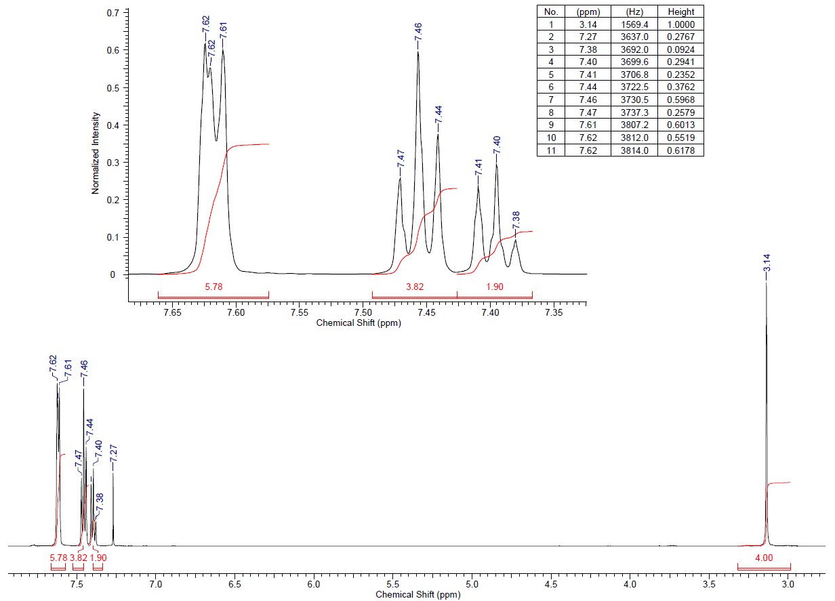

**APPENDIX B:** HMQC NMR Data for dibenzylidenecyclopentanone (zoomed in on next page)

